**CHAPTER 4**

**PROPOSED SYSTEM**

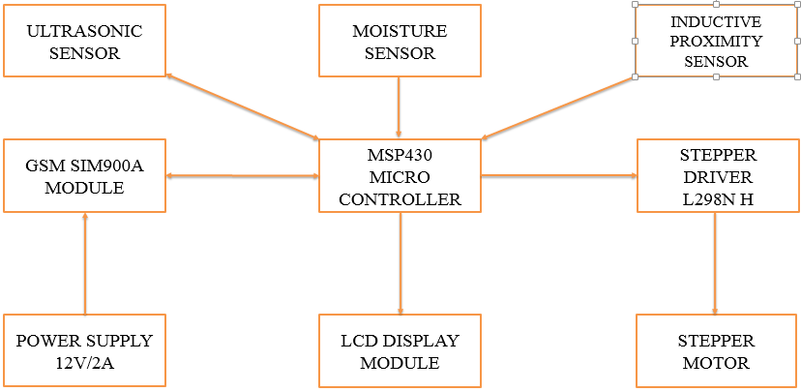

**Figure 4.1 Block Diagram of Proposed System**

In this project the MSP430 is used as a main controller for the entire control of the system. It is connected with other sensors devices and motors as mentioned in the above lock diagram.

The Ultrasonic sensor is used to identify the presence of wastes and also the other Ultrasonic sensor is used to find whether the bin is full or not.

If the bin is full then the controller tells the GSM module to send an SMS message to an existing contact with the predefined context.

Then the LCD will show the text that “BIN IS FULL” to prevent the overflow. All the moving parts are controlled by the stepper motor controlled by the L298N motor diver module.

The moisture sensor and the inductive proximity sensor is used to identify the metal wastes and food wastes respectively. The entire system is powered by a 12V and 2 ampere power adapter.

The basic building blocks of this proposed system are

* LCD display
* Ultrasonic sensor
* MSP430G2 microcontroller
* GSM module
* Stepper motor
* L298N stepper motor driver
* Inductive proximity sensor
* Moisture sensor
* Buzzer

**4.1 LCD DISPLAY**

**[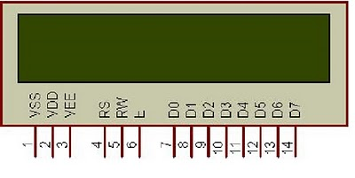](http://2.bp.blogspot.com/_becES0hCzzM/S7Qd2lrV4yI/AAAAAAAAAas/ttDl-LxEb0I/s1600/untitled.bmp)**

**Figure 4.2 LCD display**

A liquid crystal display  is a [flat panel display](http://en.wikipedia.org/wiki/Flat_panel_display), [electronic visual display](http://en.wikipedia.org/wiki/Electronic_visual_display), or [video display](http://en.wikipedia.org/wiki/Video_display) that uses the light modulating properties of [liquid crystals](http://en.wikipedia.org/wiki/Liquid_Crystals). Liquid crystals do not emit light directly. LCDs are available to display arbitrary images or fixed images which can be displayed or hidden, such as preset words, digits, and [7-segment](http://en.wikipedia.org/wiki/7-segment) displays as in a [digital clock](http://en.wikipedia.org/wiki/Digital_clock).

**VSS, VDD and VEE**

Pin 1 (VSS) is a ground pin and it is certainly needed that this pin should be grounded for LCD to work properly. VEE and VDD are given +5 volts normally. However VEE may have a potentiometer voltage divider network to get the contrast adjusted. But VDD is always at +5V.

**RS, R/W and E**

These three pins are numbered 4, 5 and 6 as shown above. RS is used to make the selection between data and command register.

For RS=0, command register is selected and for RS=1 data register is selected. R/W gives you the choice between writing and reading. If set (R/W=1) reading is enabled. R/W=0 when writing.

Enable pins is used by the LCD to latch information presented to its data pins. When data is supplied to data pins, a high to low pulse must be applied to this pin in-order for the LCD to latch in the data present at the data pins. It may be noted here that the pulse must be of minimum 450ns wide.

**D0-D7**

The 8-bit data pins, D0-D7, are used to send information to the LCD or read the contents of LCD's internal register.

**4.2 ULTRASONIC SENSOR**

Switch is used for activating the mode normal or CRN mode In [electrical engineering](https://en.wikipedia.org/wiki/Electrical_engineering), a switch is an [electrical component](https://en.wikipedia.org/wiki/Electrical_component) that can break an [electrical circuit](https://en.wikipedia.org/wiki/Electrical_circuit), interrupting the [current](https://en.wikipedia.org/wiki/Electric_current) or diverting it from one conductor to another. The mechanism of a switch removes or restores the conducting path in a circuit when it is operated.

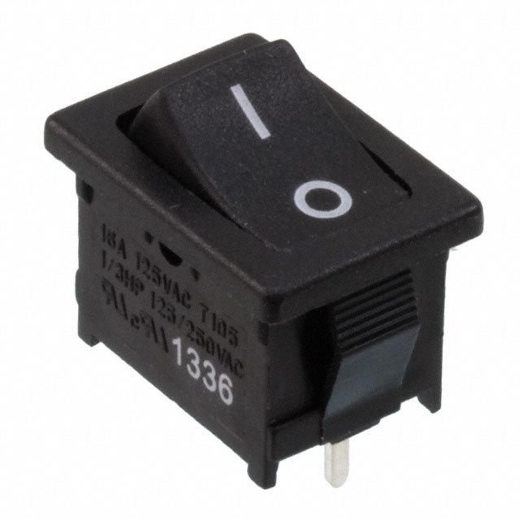

**Figure 4.3 Ultrasonic sensor**

**4.3 MSP430G2 MICROCONTROLLER**

An Arduino is actually a microcontroller based kit which can be either used directly by purchasing from the vendor or can be made at home using the components, owing to its open source hardware feature. It is basically used in communications and in controlling or operating many devices. It was founded by Massimo Banzi and David Cuartielle in 2005.

[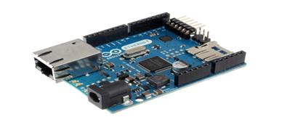](https://www.elprocus.com/wp-content/uploads/2013/08/1.jpg)

**Figure 4.4 MSP430G2 board**

**4.3.1 MSP430G2 Architecture:**

Arduino’s processor basically uses the Harvard architecture where the program code and program data have separate memory.

It consists of two memories- Program memory and the data memory. The code is stored in the flash program memory, whereas the data is stored in the data memory.

The Atmega328 has 32 KB of flash memory for storing code 2 KB of SRAM and 1 KB of EEPROM and operates with a clock speed of 16MHz.

[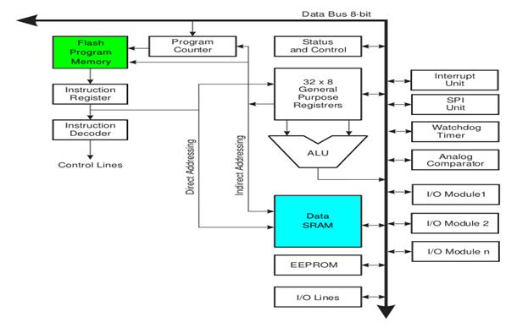](https://www.elprocus.com/wp-content/uploads/2013/08/2.jpg)

**Figure 4.5 MSP430G2Architecture**

**4.3.2 Working of MSP430G2**

The most important advantage with Arduino is the programs can be directly loaded to the device without requiring any hardware programmer to burn the program.

This is done because of the presence of the 0.5KB of Boot loader which allows the program to be burned into the circuit.

The Arduino tool window consists of the toolbar with the buttons like verify, upload, new, open, save, serial monitor. It also consists of a text editor to write the code, a message area which displays the feedback like showing the errors, the text console which displays the output and a series of menus like the File, Edit, Tools menu.

**4.3.3 Programming in MSP430G2**

[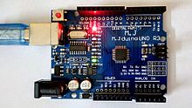](https://en.wikipedia.org/wiki/File:Power_and_Pin13_LED_on_Arduino_Compatible_Board.jpg)

**Figure 4.6 Programming in MSP430G2**

A minimal Arduino C/C++ program consist of only two functions:

* Setup (): This function is called once when a sketch starts after power-up or reset. It is used to initialize variables, input and output pin modes, and other libraries needed in the sketch.
* Loop (): After setup () has been called, function loop () is executed repeatedly in the main program. It controls the board until the board is powered off or is reset.

Most Arduino boards contain a [light-emitting diode](https://en.wikipedia.org/wiki/Light-emitting_diode)  and a load resistor connected between pin 13 and ground, which is a convenient feature for many tests and program functions. A typical program for a beginning Arduino programmer blinks a LED repeatedly.

#define LED_PIN 13 // Pin number attached to LED.

Void setup () {

Pin Mode (LED_PIN, OUTPUT); // Configure pin 13 to be a digital output.

}

void loop() {

digitalWrite(LED_PIN, HIGH); // Turn on the LED.

delay(1000); // Wait 1 second (1000 milliseconds).

digitalWrite(LED_PIN, LOW); // Turn off the LED.

delay(1000); // Wait 1 second.

}

This program uses the functions pinMode(), digitalWrite(), and delay(), which are provided by the internal libraries included in the IDE environment. The program is usually loaded in the Arduino by the manufacturer.

**4.3.4 ATMega 328 Microcontroller**

The Atmel [8-bit](https://en.wikipedia.org/wiki/8-bit) [AVR](https://en.wikipedia.org/wiki/Atmel_AVR) [RISC](https://en.wikipedia.org/wiki/Reduced_instruction_set_computing)-based microcontroller combines 32 kB [ISP](https://en.wikipedia.org/wiki/In-system_programming) [flash](https://en.wikipedia.org/wiki/Flash_memory) memory with read-while-write capabilities.

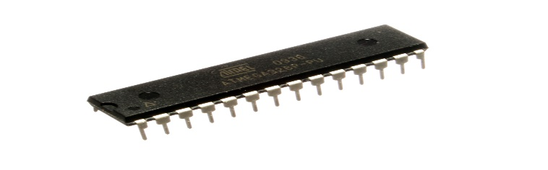

**Figure 4.7 ATMega 328 Microcontroller**

It also has 1 kB [EEPROM](https://en.wikipedia.org/wiki/EEPROM), 2 kB [SRAM](https://en.wikipedia.org/wiki/Static_random-access_memory), 23 general purpose I/O lines, 32 general purpose working [registers](https://en.wikipedia.org/wiki/Processor_register), three flexible timer/[counters](https://en.wikipedia.org/wiki/Counter_(digital)) with compare modes, internal and external [interrupts](https://en.wikipedia.org/wiki/Interrupt), serial programmable [USART](https://en.wikipedia.org/wiki/USART), a byte-oriented 2-wire serial interface, [SPI](https://en.wikipedia.org/wiki/Serial_Peripheral_Interface_Bus) serial port, 6-channel 10-bit [A/D converter](https://en.wikipedia.org/wiki/A/D_converter), programmable [watchdog timer](https://en.wikipedia.org/wiki/Watchdog_timer) with internal [oscillator](https://en.wikipedia.org/wiki/Electronic_oscillator), and five software selectable power saving modes. The device operates between 1.8-5.5 volts.

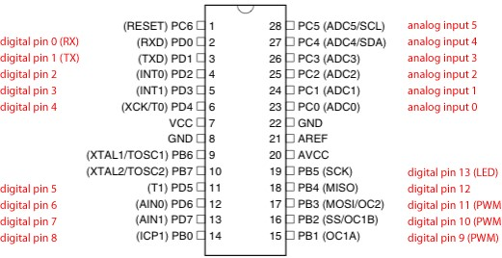

**Figure 4.8 Arduino Pin Diagram**

**4.3.5 Program Mode**

|  |  |  |  |
| --- | --- | --- | --- |
| **Programming signal** | **Pin Name** | **I/O** | **Function** |
| RDY/BSY | PD1 | O | High means the MCU is ready for a new command, otherwise busy. |
| OE | PD2 | I | Output Enable (Active low) |
| WR | PD3 | I | Write Pulse (Active low) |
| BS1 | PD4 | I | Byte Select 1 (“0” = Low byte, “1” = High byte) |
| XA0 | PD5 | I | XTAL Action bit 0 |
| XA1 | PD6 | I | XTAL Action bit 1 |
| PAGEL | PD7 | I | Program memory and EEPROM Data Page Load |
| BS2 | PC2 | I | Byte Select 2 (“0” = Low byte, “1” = 2nd High byte) |
| DATA | PC[1:0]:PB[5:0] | I/O | Bi-directional data bus (Output when OE is low) |

**Table 4.1 Parallel Program mode of Arduino**

|  |  |  |  |
| --- | --- | --- | --- |
| **Symbol** | **Pins** | **I/O** | **Description** |
| MOSI | PB3 | I | Serial data in |
| MISO | PB4 | O | Serial Data out |
| SCK | PB5 | I | Serial Clock |

**Table 4.2 Serial Program mode of Arduino**

**4.3.6 Key Parameters**

|  |  |
| --- | --- |
| **Parameter** | **Value** |
| CPU type | 8-bit AVR |
| Performance | 20 [MIPS](https://en.wikipedia.org/wiki/Instructions_per_second) at 20 MHz |
| [Flash memory](https://en.wikipedia.org/wiki/Flash_memory) | 32 kB |
| [SRAM](https://en.wikipedia.org/wiki/Static_random-access_memory) | 2 kB |
| [EEPROM](https://en.wikipedia.org/wiki/EEPROM) | 1 kB |
| Pin count | 28-pin [PDIP](https://en.wikipedia.org/wiki/Dual_in-line_package), [MLF](https://en.wikipedia.org/wiki/Quad_Flat_No-leads_package#Variants), 32-pin [TQFP](https://en.wikipedia.org/wiki/Quad_Flat_Package), MLF |
| Maximum operating frequency | 20 MHz |
| Number of touch channels | 16 |
| Hardware QTouch Acquisition | No |
| Maximum I/O pins | 23 |
| External interrupts | 2 |
| [USB](https://en.wikipedia.org/wiki/USB) Interface | No |
| USB Speed | – |

**Table 4.3 Parameter and Values of Arduino**

**4.3.7 Applications**

* [Arduboy](https://en.wikipedia.org/wiki/Arduboy), a [handheld game console](https://en.wikipedia.org/wiki/Handheld_game_console) based on Arduino
* Arduino Motion Control Rig
* [Arduinome](https://en.wikipedia.org/wiki/Arduinome), a [MIDI controller](https://en.wikipedia.org/wiki/MIDI_controller) device that mimics the [Monomer](https://en.wikipedia.org/wiki/Monome)
* ArduinoPhone, a do-it-yourself cellphone
* [Ardupilot](https://en.wikipedia.org/wiki/Ardupilot), drone software and hardware
* [ArduSat](https://en.wikipedia.org/wiki/ArduSat), a cube sat based on Arduino.
* Automatic titration system based on Arduino and stepper motor
* [C-STEM Studio](https://en.wikipedia.org/wiki/C-STEM_Studio), a platform for hands-on integrated learning of computing, science, technology, engineering, and mathematics (C-STEM) with robotics.
* DC motor control using Arduino and H-Bridge
* Gameduino, an Arduino shield to create retro 2D video games
* Homemade CNC using Arduino and DC motors with close loop control by Homofaciens
* Impedance sensor system to detect bovine milk adulteration
* Low cost data glove for virtual reality applications
* [OBDuino](https://en.wikipedia.org/wiki/OBDuino), a [trip computer](https://en.wikipedia.org/wiki/Trip_computer) that uses the [on-board diagnostics](https://en.wikipedia.org/wiki/On-board_diagnostics) interface found in most modern cars
* Water quality testing platform
* Xoscillo, an open-source [oscilloscope](https://en.wikipedia.org/wiki/Oscilloscope)

**4.4 GSM MODULE**

In generally, the wireless systems designer has two overriding constraints: it must operate over a certain distance and transfer a certain amount of information within a data rate. The RF modules are very small in dimension and have a wide operating voltage range i.e. 3V to 12V.

An RF module is a small electronic device used to transmit and/or receive radio signals between two devices. In an [embedded system](https://en.wikipedia.org/wiki/Embedded_system) it is often desirable to communicate with another device [wirelessly](https://en.wikipedia.org/wiki/Wireless). This wireless communication may be accomplished through [optical communication](https://en.wikipedia.org/wiki/Free-space_optical_communication) or through [radio](https://en.wikipedia.org/wiki/Radio) frequency communication. For many applications the medium of choice is RF since it does not require line of sight.

RF communications incorporate a [transmitter](https://en.wikipedia.org/wiki/Transmitter) and a [receiver](https://en.wikipedia.org/wiki/Receiver_(radio)). They are of various types and ranges. Some can transmit up to 500 feet. RF modules are widely used in electronic design owing to the difficulty of designing radio circuitry. Good electronic radio design is notoriously complex because of the sensitivity of radio circuits and the accuracy of components and layouts required to achieve operation on a specific frequency.

RF modules are most often used in medium and low volume products for consumer applications such as garage door openers, wireless alarm or monitoring systems, [industrial remote controls](https://en.wikipedia.org/wiki/Remote_controls), smart sensor applications, and [wireless home automation systems](https://en.wikipedia.org/wiki/Home_automation).

They are sometimes used to replace older [infra-red](https://en.wikipedia.org/wiki/Infra_red) communication designs as they have the advantage of not requiring line-of-sight operation.Several carrier frequencies are commonly used in commercially available RF modules, including those in the [industrial, scientific and medical (ISM) radio bands](https://en.wikipedia.org/wiki/ISM_band) such as 433.92 MHz, 915 MHz, and 2400 MHz.

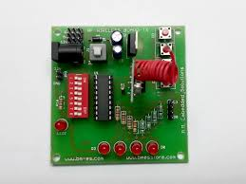

**Figure 4.9 GSM Module**

This RF module comprises of an RF Transmitter and an RF Receiver. The transmitter/receiver pair operates at a frequency of 434 MHz.

An RF transmitter receives serial data and transmits it wirelessly through RF through its antenna connected at pin4.

The transmission occurs at the rate of 1Kbps - 10Kbps.The transmitted data is received by an RF receiver operating at the same frequency as that of the transmitter.

The RF module is often used alongwith a pair of encoder/decoder. The encoder is used for encoding parallel data for transmission feed while reception is decoded by a decoder. [HT12E](http://www.engineersgarage.com/content/ht12e)-[HT12D](http://www.engineersgarage.com/content/ht12d), HT640-HT648, etc. are some commonly used encoder/decoder pair ICs.

**4.4.1 Pin Diagram of GSM Module:**

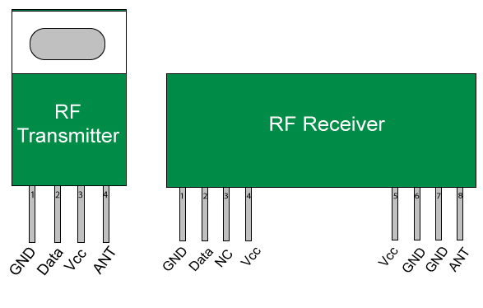

**Fig 4.10 GSM module Pin diagram**

**4.4.2 Pin Description:**

|  |  |  |
| --- | --- | --- |
| **Pin No** | **Function** | **Name** |
| 1 | Ground (0V) | Ground |
| 2 | Serial data input pin | Data |
| 3 | Supply voltage; 5V | Vcc |
| 4 | Antenna output pin | ANT |

**Table 4.4 GSM module Pin Description**

|  |  |  |
| --- | --- | --- |
| **Pin No** | **Function** | **Name** |
| 1 | Ground (0V) | Ground |
| 2 | Serial data output pin | Data |
| 3 | Linear output pin; not connected | NC |
| 4 | Supply voltage; 5V | Vcc |
| 5 | Supply voltage; 5V | Vcc |
| 6 | Ground (0V) | Ground |
| 7 | Ground (0V) | Ground |
| 8 | Antenna input pin | ANT |

**Table 4.5 RF Receiver Pin Description**

**4.5 STEPPER MOTOR**

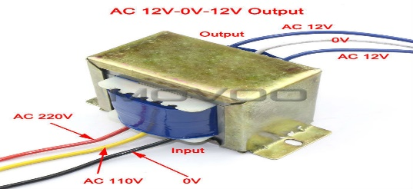

**Fig 4.11 Transformer**

A transformer is an electrical device that transfers electrical energy between two or more [circuits](https://en.wikipedia.org/wiki/Electrical_network) through [electromagnetic induction](https://en.wikipedia.org/wiki/Electromagnetic_induction). A varying current in one coil of the transformer produces a varying magnetic field, which in turn induces a varying [electromotive force](https://en.wikipedia.org/wiki/Electromotive_force) [voltage](https://en.wikipedia.org/wiki/Voltage) in a second coil.

Transformers are used to increase or decrease the alternating voltages in electric power applications.

A wide range of transformer designs is encountered in electronic and electric power applications. Transformers range in size from [RF](https://en.wikipedia.org/wiki/Radio_Frequency) transformers less than a cubic centimeter in volume to units interconnecting the [power grid](https://en.wikipedia.org/wiki/Power_grid) weighing hundreds of tons.

**4.6 L298N STEPPER MOTOR DRIVER**

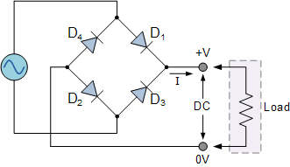

**Fig 4.12 L298N driver**

A rectifier is an electrical device that [converts](https://en.wikipedia.org/wiki/Electric_power_conversion) [alternating current](https://en.wikipedia.org/wiki/Alternating_current) , which periodically reverses direction, to [direct current](https://en.wikipedia.org/wiki/Direct_current), which flows in only one direction. The process is known as rectification.

**4.6.1 Operation**

When four diodes are connected as shown in figure, the circuit is called as bridge rectifier. The input to the circuit is applied to the diagonally opposite corners of the network, and the output is taken from the remaining two corners. Let us assume that the transformer is working properly and there is a positive potential, at point A and a negative potential at point B. the positive potential at point A will forward bias D3 and reverse bias D4.

The negative potential at point B will forward bias D1 and reverse D2. At this time D3 and D1 are forward biased and will allow current flow to pass through them; D4 and D2 are reverse biased and will block current flow. The path for current flow is from point B through D1, up through RL, through D3, through the secondary of the transformer back to point B. this path is indicated by the solid arrows. Waveforms (1) and (2) can be observed across D1 and D3.

One-half cycle later the polarity across the secondary of the transformer reverse, forward biasing D2 and D4 and reverse biasing D1 and D3. Current flow will now be from point A through D4, up through RL, through D2, through the secondary of T1, and back to point A. This path is indicated by the broken arrows. Waveforms (3) and (4) can be observed across D2 and D4. The current flow through RL is always in the same direction. In flowing through RL this current develops a voltage corresponding to that shown waveform (5). Since current flows through the load during both half cycles of the applied voltage, this bridge rectifier is a full-wave rectifier.

One advantage of a bridge rectifier over a conventional full-wave rectifier is that with a given transformer the bridge rectifier produces a voltage output that is nearly twice that of the conventional full-wave circuit. This may be shown by assigning values to some of the components shown in views A and B. assume that the same transformer is used in both circuits. The peak voltage developed between points X and y is 1000 volts in both circuits. In the conventional full-wave circuit shown in view A, the peak voltage from the center tap to either X or Y is 500 volts. Since only one diode can conduct at any instant, the maximum voltage that can be rectified at any instant is 500 volts.

The maximum voltage that appears across the load resistor is nearly-but never exceeds-500 v0lts, as result of the small voltage drop across the diode. In the bridge rectifier shown in view B, the maximum voltage that can be rectified is the full secondary voltage, which is 1000 volts. Therefore, the peak output voltage across the load resistor is nearly 1000 volts. With both circuits using the same transformer, the bridge rectifier circuit produces a higher output voltage than the conventional full-wave rectifier circuit.

Rectifiers have many uses, but are often found serving as components of DC [power supplies](https://en.wikipedia.org/wiki/Power_supplies) and [high-voltage direct current](https://en.wikipedia.org/wiki/High-voltage_direct_current) power transmission systems. Rectification may serve in roles other than to generate direct current for use as a source of power. As noted, [detectors](https://en.wikipedia.org/wiki/Detector_(radio)) of [radio](https://en.wikipedia.org/wiki/Radio) signals serve as rectifiers. In gas heating systems [flame rectification](https://en.wikipedia.org/wiki/Flame_rectification) is used to detect presence of a flame.

Because of the alternating nature of the input AC [sine wave](https://en.wikipedia.org/wiki/Sine_wave), the process of rectification alone produces a DC current that, though unidirectional, consists of pulses of current. Many applications of rectifiers, such as power supplies for radio, television and computer equipment, require a steady constant DC current .

In these applications the output of the rectifier is smoothed by an [electronic filter](https://en.wikipedia.org/wiki/Electronic_filter), which may be a [capacitor](https://en.wikipedia.org/wiki/Capacitor), [choke](https://en.wikipedia.org/wiki/Choke_(electronics)), or set of capacitors, chokes and [resistors](https://en.wikipedia.org/wiki/Resistor), possibly followed by a [voltage regulator](https://en.wikipedia.org/wiki/Voltage_regulator) to produce a steady current.

More complex circuitry that performs the opposite function, converting DC to AC, is called an [inverter](https://en.wikipedia.org/wiki/Inverter_(electrical)).

**4.7 INDUCTIVE PROXIMITY SENSOR**

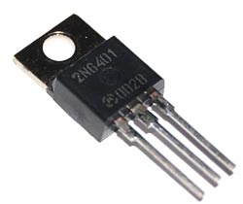

**Fig 4.13 Inductive proximity sensor**

A thyristor is a [solid-state](https://en.wikipedia.org/wiki/Solid_state_(electronics)) [semiconductor device](https://en.wikipedia.org/wiki/Semiconductor_device) with four layers of alternating [P-](https://en.wikipedia.org/wiki/P-type_semiconductor) and [N-type](https://en.wikipedia.org/wiki/N-type_semiconductor) materials. It acts exclusively as a [bistable](https://en.wikipedia.org/wiki/Flip-flop_(electronics)) switch, conducting when the gate receives a current trigger, and continuing to conduct while the voltage across the device is not reversed. A three-lead thyristor is designed to control the larger current of its two leads by combining that current with the smaller current of its other lead, known as its control lead. In contrast, a two-lead thyristor is designed to switch on if the potential difference between its leads is sufficiently large.Some sources define [silicon-controlled rectifier](https://en.wikipedia.org/wiki/Silicon-controlled_rectifier) and thyristor as synonymous. Other sources define thyristors as a larger set of devices with at least four layers of alternating N and P-type material.

Thyristors are mainly used where high currents and voltages are involved, and are often used to control [alternating currents](https://en.wikipedia.org/wiki/Alternating_current), where the change of polarity of the current causes the device to switch off automatically, referred to as "[zero cross](https://en.wikipedia.org/wiki/Zero_cross_circuit)" operation. The device can be said to operate synchronously; being that, once the device is triggered, it conducts current in phase with the voltage applied over its cathode to anode junction with no further gate modulation being required, i.e., the device is biased fully on. This is not to be confused with asymmetrical operation, as the output is unidirectional, flowing only from cathode to anode, and so is asymmetrical in nature.

**4.8 MOISTURE SENSOR**

Zigbee is a low-cost, low-power, [wireless mesh network](https://en.wikipedia.org/wiki/Wireless_mesh_network) standard targeted at battery-powered devices in wireless control and monitoring applications. Zigbee delivers low-latency communication. Zigbee chips are typically integrated with radios and with microcontrollers. Zigbee operates in the industrial, scientific and medical radio bands: 2.4 GHz in most jurisdictions worldwide; though some devices also use 784 MHz in China, 868 MHz in Europe and 915 MHz in the USA and Australia, however even those regions and countries still use 2.4 GHz for most commercial Zigbee devices for home use. Data rates vary from 20 kbit/s to 250 kbit/s.

Zigbee builds on the [physical layer](https://en.wikipedia.org/wiki/Physical_layer) and [media access control](https://en.wikipedia.org/wiki/Media_access_control) defined in [IEEE standard 802.15.4](https://en.wikipedia.org/wiki/IEEE_802.15.4) for low-rate wireless personal area networks. The specification includes four additional key components: network layer, application layer, Zigbee Device Objects and manufacturer-defined application objects. ZDOs are responsible for some tasks, including keeping track of device roles, managing requests to join a network, as well as device discovery and security.

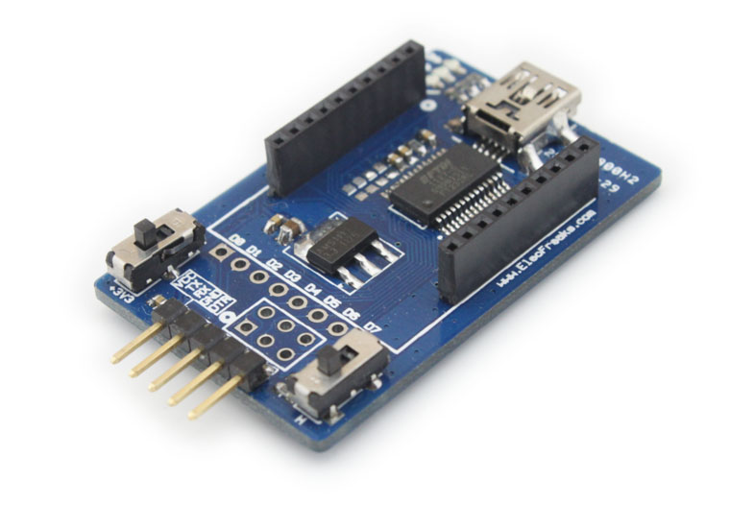

**Fig 4.14 Moisture sensor**

**4.9 BUZZER**

A buzzer or beeper is an [audio](https://en.wikipedia.org/wiki/Sound) signaling device, which may be [mechanical](https://en.wikipedia.org/wiki/Machine), [electromechanical](https://en.wikipedia.org/wiki/Electromechanics), or [piezoelectric](https://en.wikipedia.org/wiki/Piezoelectricity). Typical uses of buzzers and beepers include [alarm devices](https://en.wikipedia.org/wiki/Alarm_devices), [timers](https://en.wikipedia.org/wiki/Timer), and confirmation of user input such as a mouse click or keystroke.

In our project when primary spectrum is overloaded the buzzer will be automatically ON.

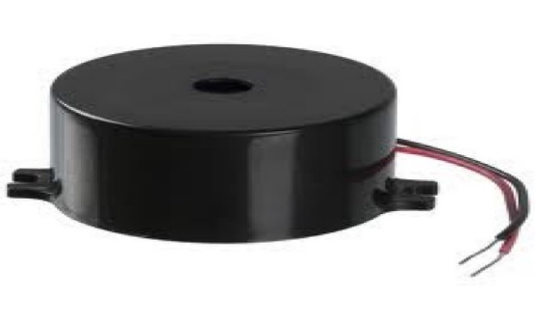

**Fig 4.15 Buzzer**